**UVC CONTROL ENCLOSURE**

**User Manual & Safety Instructions**

D0x0056-00

|  |  |  |  |
| --- | --- | --- | --- |
| **REVISION HISTORY** | | | |
| **REV** | **DATE** | **COMMENTS** | **BY** |
| A | 2020-07-24 | INITIAL RELEASE | D. WHITE |
| B | 2020-09-03 | EDITS | D. WHITE |

**TABLE OF CONTENTS**

**SECTION 1 - IMPORTANT SAFETY INSTRUCTIONS**

1. **SAFETY WARNING & DISCLAIMER**
2. **Personal Protective Equipment**
3. **Safety Features & Considerations**
4. **Markings**
5. **Lamp Bulbs**

**SECTION 2 - DEVICE OPERATION**

1. **Theory of Operation**
2. **Machine Diagram**
3. **Controls**
4. **Initial Start-up / Getting Started**
5. **Mechanical Specifications**
6. **Electrical Specifications**
7. **Sensor Circuit**
8. **Software Updates & Security**

**APPENDIX A - DIP SWITCH & EXPOSURE SETTINGS**

**APPENDIX B - USB-SERIAL INTERFACE CONFIGURATION**

**APPENDIX C - SERIAL OUTPUT DATA FIELDS**

**APPENDIX D - REPLACEMENT PARTS**

**SECTION 1 - IMPORTANT SAFETY INSTRUCTIONS**

**1. SAFETY WARNING & DISCLAIMER**

The UVC Control Enclosure (“machine”) is provided without any warranty, express or implied. The machine was developed in the interest of benefiting the scientific community, during the 2020 COVID-19 pandemic, and is offered on the condition that its creator built it in good faith, and shall not be held liable for damage to property or personal injury that occurs as a result of its use. The machine is provided for use by qualified persons only. The machine is not a medical device, and it does not treat or prevent any disease. The device produces high-energy ultraviolet C-band radiation that can cause severe damage to the eyes and skin. The ultraviolet lamps react with air to create ozone, which is a known toxin. The user is responsible for reading this document in its entirety, responsible for the machine’s safe use, and must take all necessary precautions to ensure personal safety while operating the equipment.

**2. Personal Protective Equipment (PPE)**

The user shall use personal protective equipment at all times. Recommended PPE at minimum:

* UVC (100-280 nm) protective eyewear
* Surgical mask for covering face
* Gloves, shirt sleeves, shoes, and pants for covering all exposed skin
* Use cabinet in a well-ventilated area

**3. Safety Features & Considerations**

* *Electrical - mains:* the primary power circuit is grounded, single-phase 60Hz, 120Vac. It is protected by a UL 489 circuit breaker.
* *Electrical - low voltage:* the low voltage electronics are protected by an isolated, UL-listed Class 2 power supply. The low voltage components are physically separated from the primary circuit via galvanic or functional isolation, insulation, and physical spacings.
* *Enclosure*: The machine primarily provides protection to the user by means of its fully enclosed construction. That is, the enclosure prevents exposure to UVC irradiance when the door is sealed, and the lamp circuit is active.
* *UVC cut-off switch*: The germicidal cabinet is equipped with an interrupt circuit that will cut off the supply to the UVC lamps if the door is opened. The box is determined to be safe to use, and the lamp circuit is *enabled* when the exterior green LED indicator is lit. **WARNING: do not defeat the door safety switch.**
* *Ozone mitigation:* no means of ventilation or ozone mitigation is provided. The user shall provide suitable ventilation, such as by locating the machine within a fume hood with adequate air flow rate. The unit should be allowed to vent into its environment after each irradiance cycle to prevent the accumulation of ozone gas.

**4. Markings**

* Nameplate:

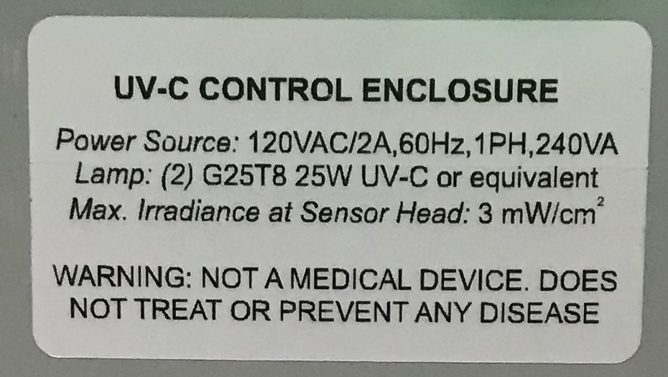

*Image 1. UVC Control Enclosure nameplate label*

* UVC label:

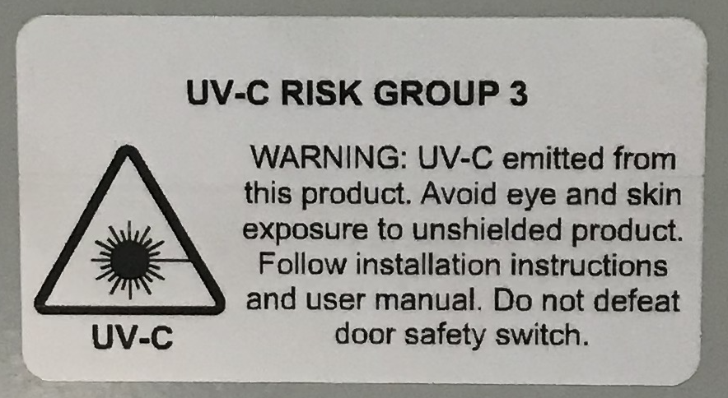

*Image 2. UVC risk label*

* Ozone label:

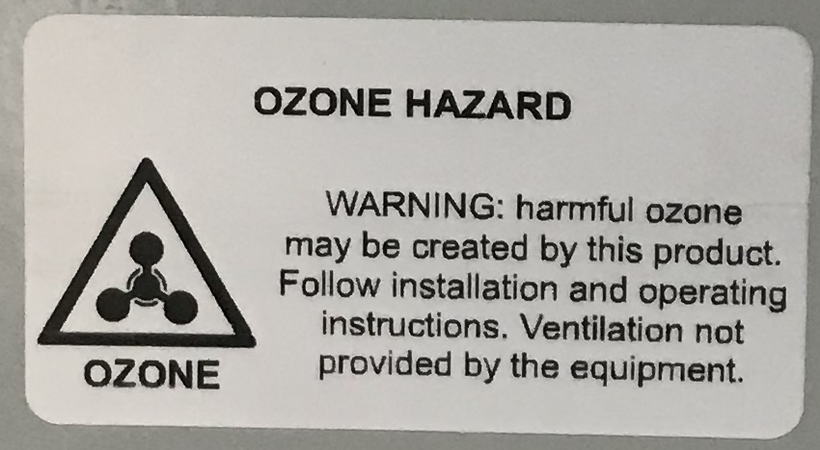

*Image 3. Ozone hazard label*

**5. Lamp Bulbs**

Warning:

* Risk of Electric Shock
* Turn power off before inspection, installation or removal.
* Lamp emits UV radiation which may cause eye/skin injury. RG-3
* Avoid exposure of eyes and skin to unshielded lamp.

Caution:

* Lamp may shatter and cause injury if broken
* Do not use excessive force when installing lamp.
* Wear safety glasses and gloves when handling lamp.

Waste / Disposal:

* Lamp Contains Mercury. Manage in accordance with disposal laws. See: www.lamprecycle.org or call 1-800-327-0097

**SECTION 2 - DEVICE OPERATION**

**6. Theory of Operation**

Ultraviolet C-band radiation comes in the wavelength of 100-280 nanometer, and has been observed to provide germicidal effects. This phenomena serves as the basis for the creation of this UVC Control Enclosure: **a device designed to 1) supply UVC irradiance, and 2) measure & report the UVC irradiance (units: mW-sec/cm2)**. The author makes no claim to the efficacy of the machine, but has taken ***reasonable steps to ensure accuracy and completeness*** in the two functions mentioned above.

**7. Machine Diagram**

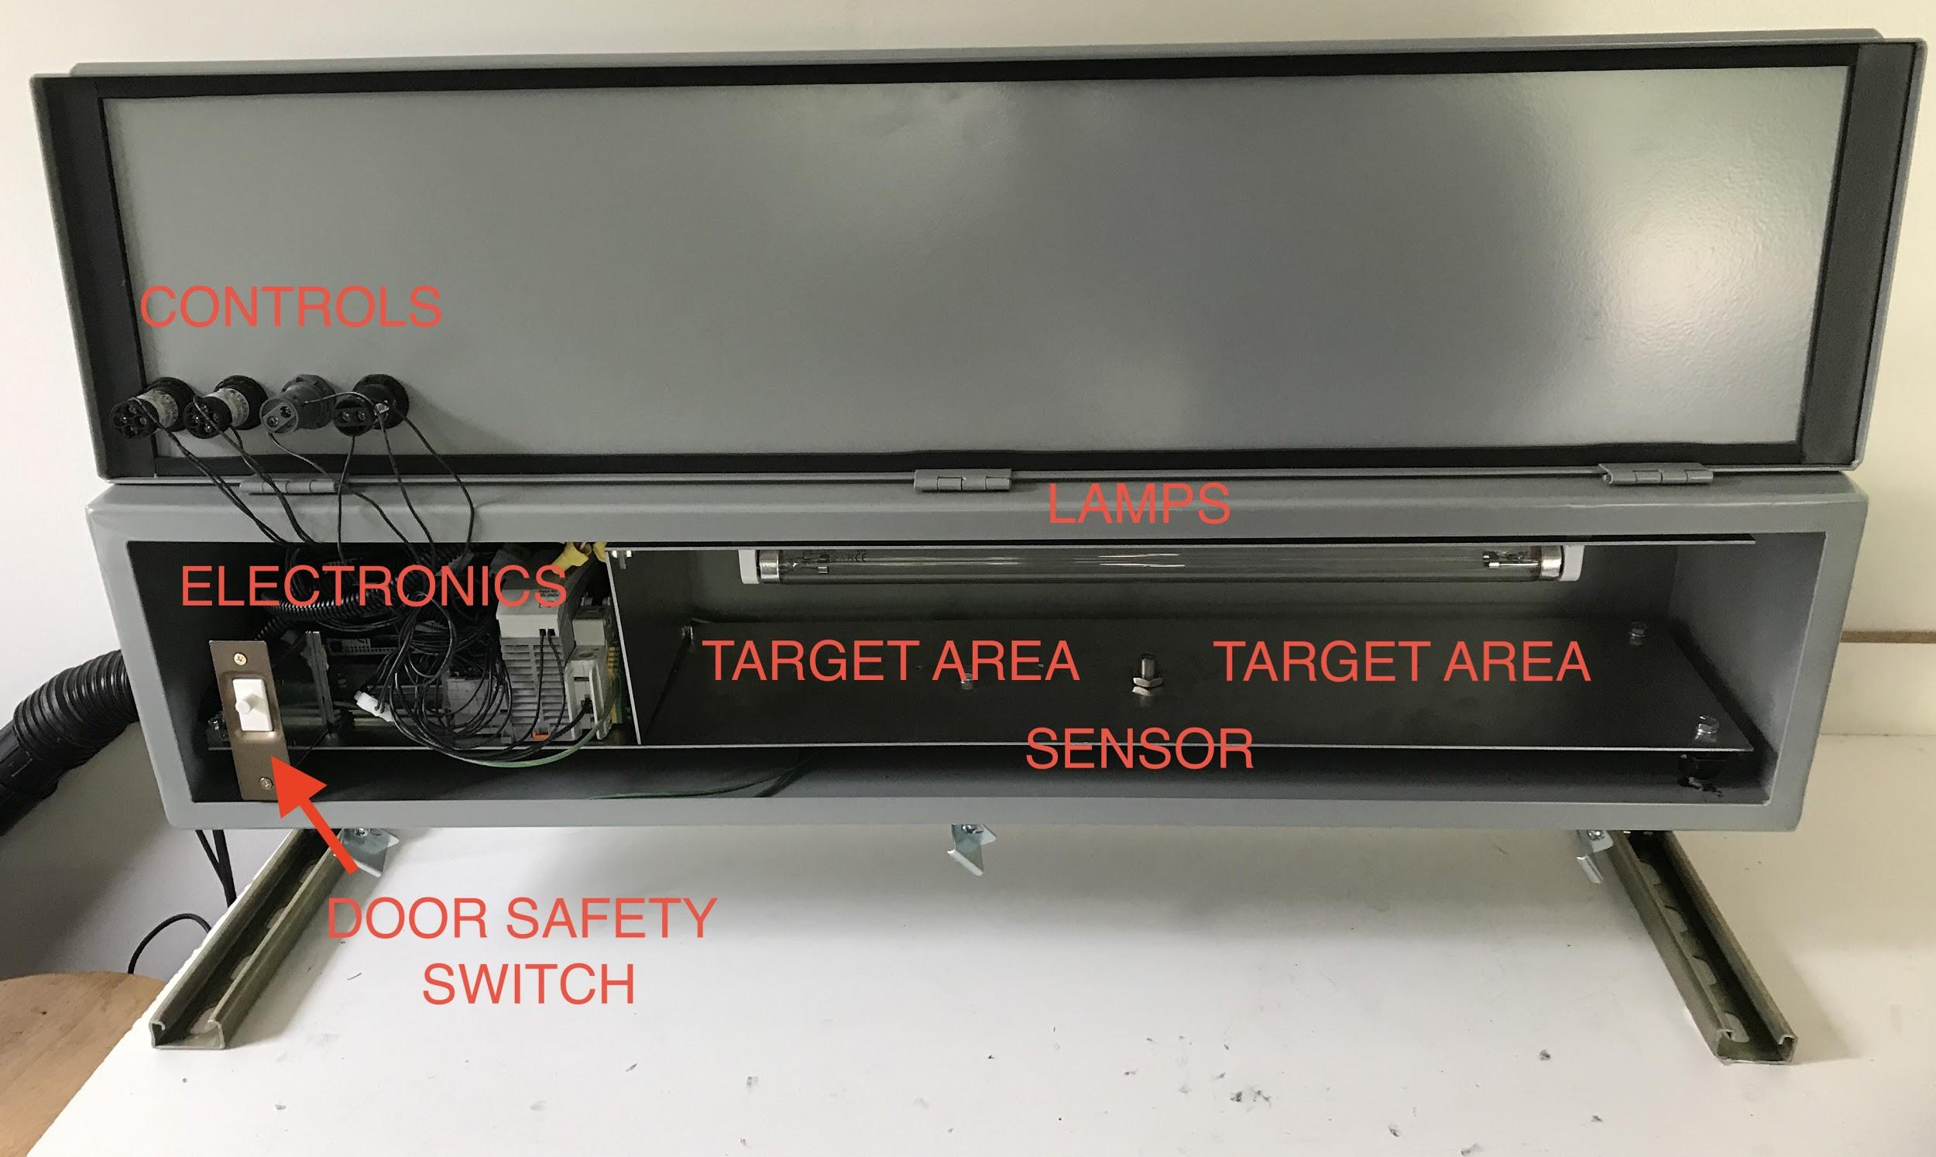

*Image 4. High-level machine components diagram*

**8. Controls**

The machine has 4 control elements on the exterior of the unit. They are:

* **START** = black, momentary pushbutton to initiate an irradiance sequence.
* **STOP** = red, momentary pushbutton to interrupt an irradiance sequence already in progress. It has no function if an irradiance sequence is not currently active.
* **ENABLE** = green, 120V LED indicator light that is on, if 1) power is supplied to the unit, 2) the internal circuit breaker is closed, and 3) the enclosure door is completely closed, ensuring completion of the door sensor safety circuit.
* **RUN** = red, 24V LED indicator. This indicator flashes once per second during an irradiance sequence. Once complete, the indicator will default to OFF. If a sequence is interrupted, it become solidly lit, indicating an ERROR.

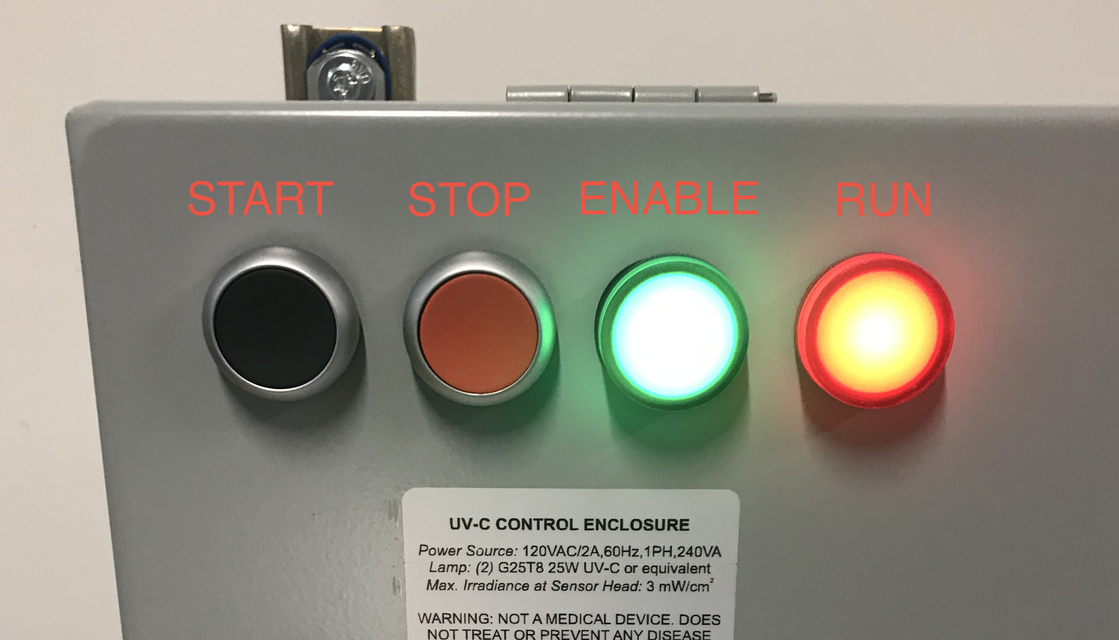

*Image 5. Exterior controls for UVC cabinet*

**9. Initial Start-up / Getting Started**

1. *Location*: locate the enclosure in a place that is well-ventilated, such as a fume-hood.
2. *Power*: the enclosure must be powered by a standard 120VAC electrical outlet (20A max), via its grounded cord and plug. **Do not plug in the power cord, yet. *Note: this equipment is not for permanent installation.***
3. After the enclosure is situated in its desired location, configure the DIP switch settings to deliver the total dose required. **Reference Appendix A for DIP switch positions and how to program the total dose or exposure settings**. Dip switches at a glance: 0 = switch low (down), and 1 = switch high (up). Allowable range is 10-800 mW-sec/cm2.
4. Plug in the power cord.
5. Plug in the USB cord to an external computer (if desired). If using a computer terminal, consult **Appendix B** on how to set-up a USB-serial interface to read the output messages from the unit.
6. “Close” or flip-up the switch on the internal circuit breaker to provide power to the lamp circuit and controller.
7. With the unit powered, it is ready to test. Close the enclosure door, and secure the door using at least one of the door latches. The green **ENABLE** indicator should illuminate.
8. Press black **START** pushbutton to start an irradiance sequence. If it is active, the red **RUN** indicator will begin to blink once per second. To interrupt, hold the red **STOP** button for one second.
9. Once the sequence is complete, the red **RUN** indicator will stop blinking.

**IMPORTANT:** note that if the door is opened mid-sequence, the machine will detect that no UV-C irradiance is being dispensed, and will interrupt the sequence, and print an error code on the serial output. This is to prevent over-exposing the sample, or running the machine for an indeterminate amount of time. It would also detect if the lamp circuit were not active. Also note that each irradiance sequence has a maximum time limit of 300 seconds (5 minutes).

**10. Mechanical Specifications**

* Enclosure is rated NEMA / UL **Type 12**: protects against dust and splashing liquids, for **indoor use only**.
* Enclosure is Hoffman Nvent catalog number F88T36HC

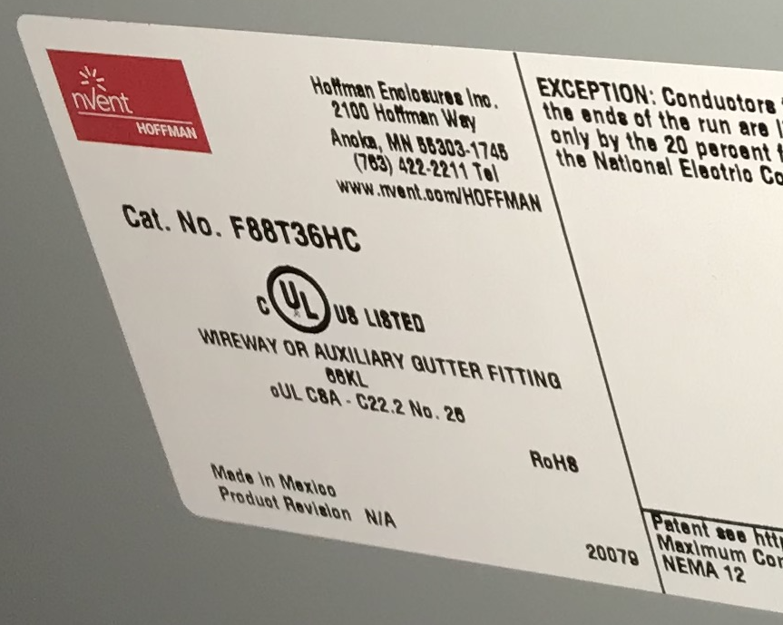

*Image 6. Enclosure manufacturer markings and ratings*

**11. Electrical Specifications**

* *Power source:* 120VAC/2A, 240VA, 1-phase, 60 Hz
* *Lamp circuit:* (2) G25T8 25W gas-vapor ultraviolet type C lamps
* *Ballast:* Fulham WH5-120-L
* Maximum Irradiance: 3 mW/cm2
* Maximum Exposure: 800 mW-sec/cm2 (mJ/cm2)
* *Sensor Type:* Silicon carbide (SiC) photodiode w/ embedded amplifier

**12. Sensor Circuit**

**CAUTION:** Sensor values, and total calculated exposure are at the sensor optical surface, and not necessarily equal to the exposure delivered to your sample. The exposure varies by location of the sample, primarily its height, or distance from the lamps.

**Sensor Details:**

* *Distributor:* Boston Electronics
* *Manufacturer:* sglux GmbH
* *Part Number:* TOCON C-7
* *Configuration:* M12 [fine] threaded stainless steel body
* *Product Information (general)*: <https://sglux.de/en/produkt/tocon_c7/>
* *Sensor Architecture:* SiC w/ integrated amplifier circuit

Calibration:

* Sensor Saturation Irradiance (maximum): 20.7 mW/cm2
* Sensor Range (nominal): 0 - 20.7 mW/cm2
* Sensor reference calibration (distance = 50mm): 0.374V at 1.545 mW/cm2
* Sensor Scale Factor (A_s): 4.1305 mW/cm2 / V
* Calibration Uncertainty: 10%

Sensor Electrical Ratings:

* Input voltage: 24VDC
* Output voltage: 0-5V (single-ended, grounded)
* Sensor Scale Factor (A_s): 4.1305 mW/cm2 / V

**13. Software Updates & Security**

The UVC Control Enclosure uses an embedded processor to control the light circuit, measure irradiance, and report information out on the serial bus, via the USB cable. The controller does not contain WiFi, bluetooth or any other radios, and does not require computer or network connection to work. Nevertheless, it contains programmable components and should therefore be protected.

**Note: that the following procedure is only needed if a software update is requested or required for the UVC Control Enclosure in the future.**

**To ensure that software downloaded to the device has not been altered** by any malicious actor, it is recommended to perform a ***checksum*** of the software before downloading it to the device. The checksum is easily performed using any Mac, PC, or Linux device.

The "controller" for the UVC cabinet is actually a microcontroller running an embedded operating system and software ("firmware"). The firmware is compiled and then able to be downloaded directly to the microcontroller via its USB cable. To ensure that the software has not been tampered with, all versions of the firmware will be provided with an SHA-256 checksum. A checksum is an algorithmic means of checking the integrity of the file. SHA-256 is just the name of the algorithm. In order to verify the integrity of the file, merely download it, and the checksum_<xxx>.txt files to the same folder, then complete the following steps.

**Verifying the checksum:**

Using a Mac OS Terminal program or Using Linux command line:

shasum -a 256 -c < checksum_R20200724C.txt

This should return the name of the file that was verified, and the words “OK”:

BIN_R20200724.bin: OK

Using Windows Prompt*:

certutil -hashfile BIN_R20200724.bin SHA256

*You will then need to compare the output from this command with the line in the cheksum text file, visually/by hand. I do not know how to compare them automatically using Windows.

**Downloading the firmware to the controller:**

* Plug in the UVC Control Enclosure’s USB cable to the computer
* Something that looks like a USB drive will show up on the desktop. It may be called “NUCLEO_F746ZG”
* Drag and drop the firmware file (ending in ***.bin***)directly to the drive.
* Wait about 10 seconds.
* Reboot the machine’s controller by toggling the internal circuit breaker from ON-OFF-ON, or just unplug, then plug the machine back in.
* Done

**APPENDIX A - DIP SWITCH & EXPOSURE SETTINGS**

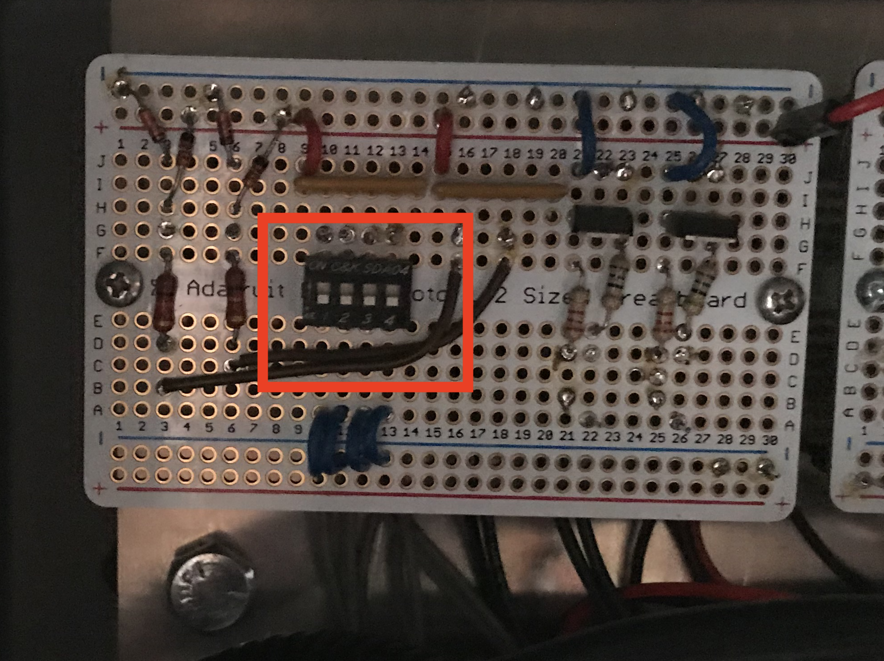

*Image 7: location of the DIP switches and the location of bits 3210*

Set the DIP switches to get the required exposure or total dose in mW-sec / cm2 (mJ/cm2). Dip switches are 0 = switch low (down), and 1 = switch high (up). Allowable range is 10-800 mW-sec/cm2. Please consult the author for additional exposure settings / ranges, which must be modified in the controller’s software.

***Caution:*** *please observe that the unit will only read the exposure time settings once, at startup. If an alternative setting is required, remove power to the unit by unplugging it, change the setting, and then turn it back on. The new setting will take effect. Changing the dip settings without restarting the unit will not change the setting in software.*

The formula for determining total exposure dose, or irradiance in mW-sec/cm2, as implemented in the controller follows:

**Irradiance = (10 * 10bit_3) * ( 22** * **bit_2 + 21 * bit_1 + 20** * **bit_0 + 1 )**

Where:

* Bit 3 = 10x or 100x scale bit
* Bit 2...0 = 3-bit binary number or “ones” place. The binary range works out to (0 to 7 ) + 1, or 1 to 8.

|  |  |  |  |  |
| --- | --- | --- | --- | --- |
| **DIP Switch Settings - Total Exposure Configuration (mW-sec/cm2)** | | | | |
| **DIP SWITCH 1** | **DIP SWITCH 2** | **DIP SWITCH 3** | **DIP SWITCH 4** | **SW positions: 1-2-3-4** |
| *Bit 3* | *Bit 2* | *Bit 1* | *Bit 0* | *Exposure (mW-sec / cm2)* |
| 0 | 0 | 0 | 0 | 10 |
| 0 | 0 | 0 | 1 | 20 |
| 0 | 0 | 1 | 0 | 30 |
| 0 | 0 | 1 | 1 | 40 |
| 0 | 1 | 0 | 0 | 50 |
| 0 | 1 | 0 | 1 | 60 |
| 0 | 1 | 1 | 0 | 70 |
| 0 | 1 | 1 | 1 | 80 |
| 1 | 0 | 0 | 0 | 100 |
| 1 | 0 | 0 | 1 | 200 |
| 1 | 0 | 1 | 0 | 300 |
| 1 | 0 | 1 | 1 | 400 |
| 1 | 1 | 0 | 0 | 500 |
| 1 | 1 | 0 | 1 | 600 |
| 1 | 1 | 1 | 0 | 700 |
| 1 | 1 | 1 | 1 | 800 |

**APPENDIX B - USB-SERIAL INTERFACE CONFIGURATION**

**CAUTION: If a laptop is plugged into the machine via USB, ensure that the laptop power cord is the two-prong (ungrounded), rather than 3-prong (grounded) type. This will prevent the possibility of a ground-loop that may be destructive to the computer or the equipment. Isolating plugs have been provided with the unit for this purpose.**

**Mac OS X**

1. If you have a Mac computer, such as Macbook Air, or Macbook Pro, open up the Terminal application from: **Applications > Utilities > Terminal.**

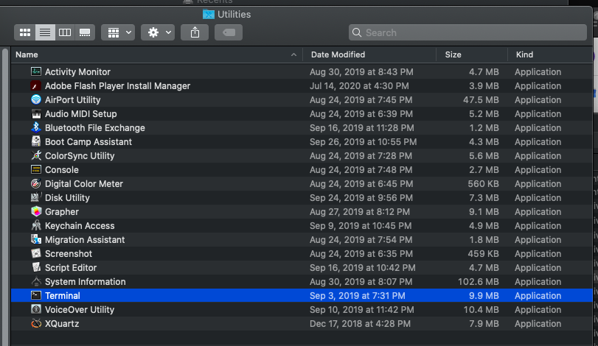

*Image 8. Finding Terminal program in Mac OS X.*

1. Plug in the UVC cabinet’s USB cable to the computer, but leave the power to the cabinet **OFF**.
2. Enter the following line on the console:

*$ ls /dev/ > dev_list_1.txt*

1. Turn on the machine, then paste and hit Enter to execute the following command:

*$ ls /dev/ | diff --suppress-common-lines -y - dev_list_1.txt*

1. You should now see the serial/USB device name for where the UVC cabinet can be accessed. Next, to read serial data output from the UVC cabinet, type in the following command:

$ screen /dev/tty.usbmodem14103 9600

Where tty.usbmodem14103 is the name or output that was found in step 4.

1. You can copy and paste the output from the Terminal window into a text editor or Excel file to save.
2. To exit, just close the Terminal program using **COMMAND + Q**.

**Windows / PC**

Download and install software: 1. Go to https://putty.org/ 2. Download the software for Windows. (choose 32 or 64 bit as appropriate) 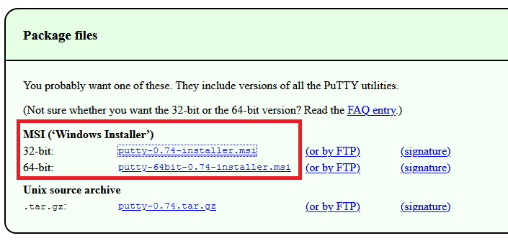

*Image 9. Putty download links for 32 or 64 bit Windows*

Locate correct COM port: 3. Plug in the USB cable from the UVC control enclosure. The device's power must be on. 4. Using the Windows search box, type "Control Panel" 5. Under "Hardware and Sound" header, click link to "View devices and printers." 6. Look for a USB device, it may be called NUCLEO-746ZG 7. Right + click --> "view properties" to identify the COM port associated with the device (ex: COM1, COM3, etc).

Read Serial Output w/ Putty: 8. With the correct COM port identified, we can now use the Putty terminal to read the serial output from the machine over USB. Open Putty.exe program. 9. In the "Category" pane of the program, navigate to the bottom left and highlight "serial." Enter the settings exactly as you see them, but adjusting the COM port number according to what is displayed in your computer for the UVC controller. (see image 10).

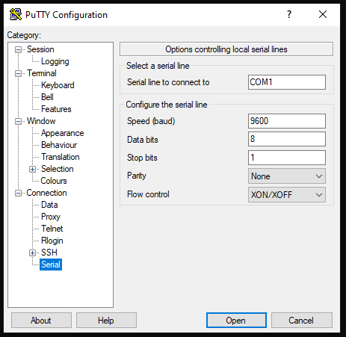

*Image 10. COM settings for Serial interface using Putty*

10. Click "Open." 11. You can now power cycle the UVC controller by opening the door, and flipping the circuit breaker, or unplugging it and plugging it back in. The serial port should display a start-up sequence and messaging related to the configuration of the machine should be printed in the terminal.

Set up a log file: 12. If you want to save the output of a session, Putty can record the output via its logging function. Just navigate to the "Category" pane, and at the top left click: Session --> Logging (see image 11).

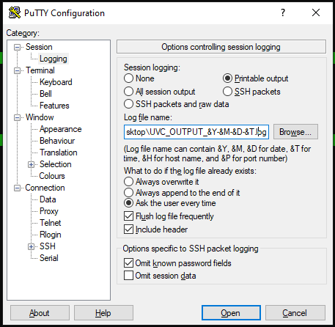

*Image 11. Putty log file output configuration settings.*

13. Choose "printable output" or "all session output", click 'Browse..." to set the folder that you want to save to, and then add the following filename (or similar) to record the date/time to each log file. The "Log File Name" field should look similar to this:

C:\Users\<USERNAME>\Path\To\Logfiles\UVC_LOG_&Y-&M-&D-&T.log.

You should now have a record of each session using the UVC control enclosure!

**APPENDIX C - SERIAL OUTPUT DATA FIELDS & ERROR CODES**

When an irradiance sequence starts, it will display the current “batch number” and a bunch of zeroes. Then, once the irradiance sequence is complete, it will report out the final data points. The following table shows a description for each of the serial output data fields:

|  |  |  |  |
| --- | --- | --- | --- |
| **SERIAL OUTPUT DATA FIELDS** | | | |
| **field** | **data_type** | **units** | **explanation** |
| batch_no | integer | NULL | The count of irradiance sequences, starting at 1, for the session |
| sample_count | integer | NULL | time or sample counter of 1-sec samples |
| voltage_raw | float | V | This is the raw voltage output for the sensor |
| dose | float | mW-sec/cm^2 | This is the total target dose of irradiance for the sample |
| gain | float | mW/cm^2 / V | sensor scale factor in units per volt |
| dose_avg | float | mW/cm^2 | Avg radiant flux (power = energy / time) for the sequence |
| dose_received | float | mW-sec/cm^2 | Irradiance is the the total energy in integrated over time |

*Table 1. Data fields reports out to command line via serial-USB output*

**Error Codes:** The state of the machine is expressed using an error code called *Exposure Control Flag*. It ranges from 0-4 and explains various ways that the main software routine may fail. Below is a list of explanations for the 5 states of the software program:

|  |  |
| --- | --- |
| **ERROR CODES** | |
| Exposure Control Flag | Explanation |
| 0 | NORMAL, SYSTEM OK |
| 1 | Irradiance sequence manually aborted (stop button interrupts irradiance sequence) |
| 2 | Irradiance sequence timed out (300 sec) and aborted. |
| 3 | Sensor is not detecting any light. Inspect sensor and lamps. Is sensor covered or obstructed by an object in the target area? |
| 4 | Sensor value is out of range (too high). |

*Table 2. List of software program error codes*

**APPENDIX D - REPLACEMENT PARTS**

|  |  |  |  |  |  |
| --- | --- | --- | --- | --- | --- |
| Item | Distributor | MFG | MFG P/N | DESC | QTY |
| Sensor | Boston Electronics | Sglux GmBH | TOCON C-7 | UVC sensor 0 - 20.7 mW/cm2, M12 SST | 1 |
| Sensor Cable | Automation Direct | N/A | CD12L-0B-020-C0 | 4-wire sensor cable, 90-deg | 1 |
| Lamp | lightbulbs.com | Philips  OR  GE | TUV 25W T8 / [**PL292680**](https://www.lightbulbs.com/product/philips-292680)  OR  GE 11082 / G25T8 | 25 watt 18" T8 Bi-Pin Base Clear Germicidal | 2 |
| Lamp Ballast | N/A | Fulham | WH5-120-L | BALLAST,120VAC,UL | 1 |
| Lamp Relay | Allied Electronics | Phoenix Contact | 2903361 | RELAY,SPST,24VDC,100-240VAC/6A | 1 |
| Circuit Breaker | Automation Direct | Eaton | FAZ-C7-1-NA-SP | MCB,UL 489, 1P, 7A | 1 |
| PB - START | Galco | Eaton | C22-D-S-K10  OR  C22-D-S-K11 | PB,MOMENTARY,1NO,BLK | 1 |
| PB - STOP | Galco | Eaton | C22-D-R-K10  OR C22-D-S-K11 | PB,MOMENTARY,1NO,RED | 1 |
| LED - ENABLE | Galco | ABB | CL-513G | LED,120VAC,GRN,TYPE 4/4x | 1 |
| LED - RUN | Galco | ABB | CL-502R | LED,24V,RED,TYPE 4/4X | 1 |
| Power Supply | Digikey | Phoenix Contact | 2902992 | PS,60W,24VDC,CLASS 2 | 1 |